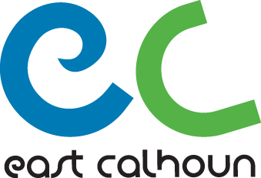

East Calhoun Community Organization

Nominees to ECCO Board Position

Please review the East Calhoun Community Organization By-Laws for information on the organization, Board Member election and responsibilities at our website:
www.eastcalhoun.org.

Nominee Information:

Name:
Address:
Phone: Email:
Describe why you are interested in nomination to the ECCO Board:

Describe any background / skills which will be assets to your work on the Board:

If this nomination is being submitted by someone other than the nominee, please provide the following information:
Name:
Address:
Phone: Email:
Describe reasons the above nominee is being recommended by you for a position on the ECCO Board:

Thank you for your interest in the ECCO Board and the East Calhoun Neighborhood!
Please send completed form to: Monica Smith, ECCO Coordinator at nrp@eastcalhoun.org or mail to: East Calhoun Community Organization 2751 Hennepin Ave S, Box 13 Minneapolis, MN 55408

